PASTIC National Centre
Quaid-i-Azam University Campus
P.O.Box 1217 Islamabad
Phone: 051-9248107
Fax: 051-9248113
E-mail: sl@pastic.gov.pk
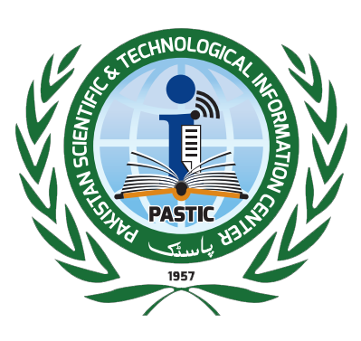

__________________________________________________________________________________

No. PNC/LIB-PC-I/2/2017 November 13, 2017

INVITATION TO BID

Pakistan Scientific and Technological Information Centre (PASTIC) is a National Agency for collection and dissemination of scientific information. PASTIC intends to invite sealed bids for the purchase of below mentioned items from well-reputed Firms or General Order Supplier having NTN & GST registration numbers which are on Active Tax Payer List (ATL) and deals in furniture items especially for library furniture:

Sr. # | Items Detail | Qty
1 | Double sided shelving Unit | 15
2 | Display shelving | 10
3 | Study Carrels | 12
4 | Sofa Single Seater | 5 Nos
5 | Sofa three Seater | 1 Nos
6 | Center table | 02
7 | Executive table with side rack | 01
8 | Low height Cabinets | 02
9 | Revolving Computer Chairs | 16
10 | Executive Chairs | 01
11 | Visitor Chairs | 04
12 | Conference Table (for 20 chairs) | 01
13 | Window blinds / Venetian blinds | 500 sqf
(Quantity can be increased or decreased)
A complete set of bidding document/detailed specifications along with terms & conditions may be collected from undersigned upto 28th November, 2017 during working hours (except holydays).

The interested Firms / Suppliers must submit their sealed bids latest by November 28th, 2017 upto 11:00am which will be opened on same day at 11:30am in PASTIC Committee Room in the presence of bidders or their representatives, who wish to attend. Pay order / demand draft equal to 5% of total bid value as earnest money must be attached with quotations in favour of PASTIC Islamabad. (cheque is not accepted) Catalogue/Brochure (if any) of furniture items may also be attached with quotations.

(Dr. Raja Razi-ul-Hasnain)
Additional Director (A &F)
PASTIC National Centre, QAU, Islamabad
Ph. 051-9248105/ 9248116

